SCUBA-2 Block Specification
tx_fifo

Table of Contents

1. Block Overview 3
1.1 Block Location and Block Interface Within System 3
1.2 Block Functionality / Features 3
1.3 Block Dataflow 3
2. Block Interfaces 4
2.1 Interface Signal Description 4
2.2 Interface Protocol and Timing 4
3. High-Level Description 5
3.1 Block Description 5
4. Files of the Block 6
4.1 Source Code 6
4.1.1 tx_fifo.vhd 6
4.1.2 sync_fifo_tx.vhd 6
4.2 Header Code 6
4.2.1 commponento_pack.vhd 6

Block Overview

Block Location and Block Interface Within System
This block is located on the clock card FPGA. It interfaces with the following blocks on the clock card:

- tx_control
- reply_translator

Block Functionality / Features
- This FIFO block acts as a buffer for bytes to be transmitted by the Cypress CY7B923 HOTLinkTM transmitter. When bytes are written to this FIFO the tx_control block enables the HOTLinkTM transmitter, which in turn reads from the FIFO and transmits the byte to the RTL PC.
- The core of the FIFO is the entity sync_fifo_tx.vhd, which is a synchronous FIFO ‘Megafunction’ created with QUARTUS II.

Block Dataflow

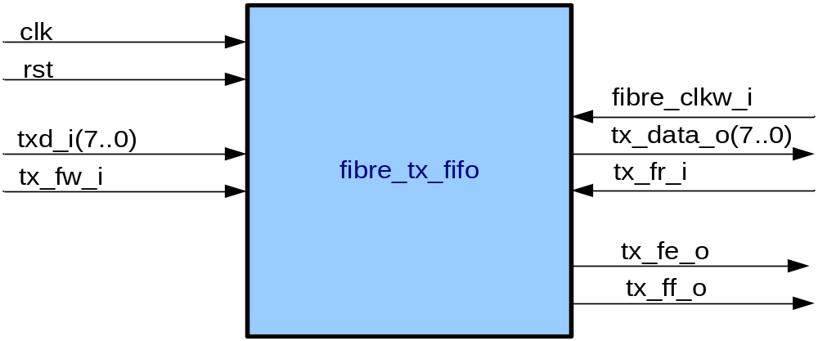

Block Interfaces

Interface Signal Description
- Interface Signals
Signal | Description | Direction
Global Signals
clk_i | Global Clock (used as FIFO write clock)
rst_i | Asynchronous FIFO reset | in
Control Signals
tx_fw_i | FIFO write enable. When asserted data on tx_data_i is written to the FIFO on the next positive edge of clk_i. | in
tx_data_i | Byte wide data input to FIFO | in
tx_fr_i | FIFO read enable. When asserted data from the FIFO is read to txd_o on the next positive edge of fibre_clkw_i. | in
fibre_clkw_i | Input signal from Hotlink transmitter. Used as FIFO read clock | in
txd_o | Byte wide data output from FIFO | out
tx_ff_o | FIFO full flag. Indicates to the reply_data_fsm block that the FIFO is full and cannot be written to. | out
tx_fe_o | FIFO empty flag. Indicates to the tx_control block that there is no data to be transmitted. | out

Interface Protocol and Timing

High-Level Description

Block Description

tx_fifo.vhd is an interface to the synchronous FIFO block “sync_fifo_tx” (created with QUARTUS II megafunction wizard).

Files of the Block

Source Code

tx_fifo.vhd
Interface to sync_fifo_tx core

sync_fifo_tx.vhd
synchronous FIFO core of tx_fifo. Created with QUARTUS II megafunction wizard.

Header Code

commponento_pack.vhd
This file contains the ‘sync_fifo_tx’ component declaration.

